**QUADRA Breakout Frontend.**

Breakout frontend is not an actual frontend that could directly be used for impedance measurement. Breakout frontend provides easy access to the pins of the QUADRA measurement connector (SubD25) to which users can populate their own measurement topology.

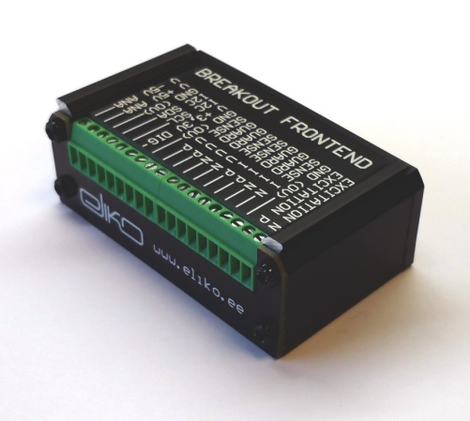

: Breakout F.E. image

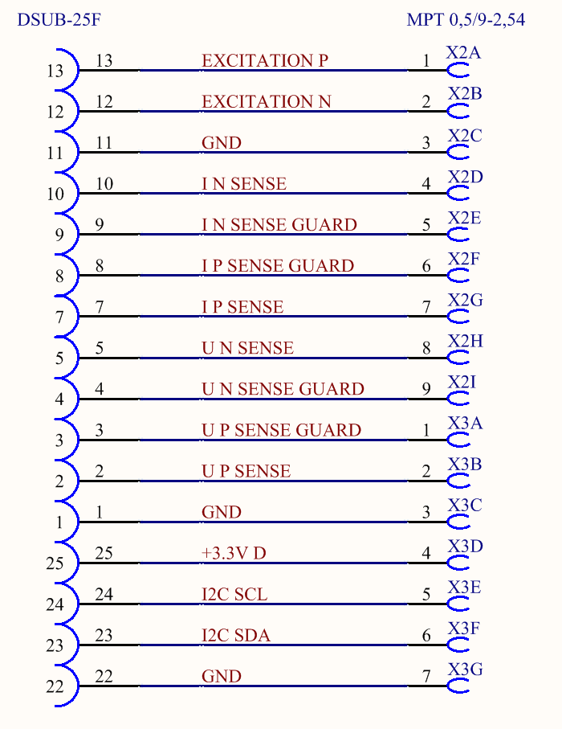

: Breakout F.E. schematic

**QUADRA Single Shunt Frontend.**

Single-Shunt frontend is the simplest, least costly , and practical for most use-cases.

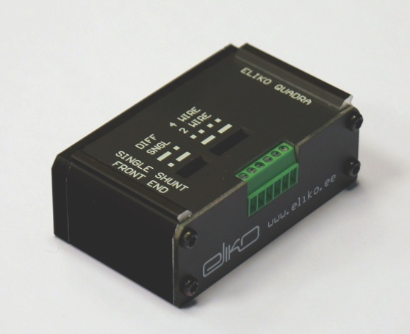

: Single Shunt F.E. image

Single-Shunt frontend configures QUADRA analyzer to work by potential divider topology. The voltage excitation is applied to a fixed value shunt R which is in series with the measured object Z.

Current flowing through Z is calculated from voltage drop on the shunt R1 with known value, and the impedance of the Z is calculated based on these values. Shunt R2 has the same value as R1 but it is not used for current measurement.

Stock shunt values are shown in table. Other values may be requested for special customization fee.

|  |  |  |
| --- | --- | --- |
| **Shunt index** | **Shunt type** | **Shunt value** |
|  | Resistor | 100Ω |
|  | Resistor | 1000Ω |
|  | Resistor | 10000Ω |
|  | Capacitor | 1nF |
|  | Capacitor | 100nF |

: Preliminary single shunt F.E. stock values

Single-Shunt frontend allows user to select between differential and unipolar excitation by relocation of a jumper J3.

Single-Shunt frontend allows to select between four wire and two wire measurement conficurations by addition or removal of jumpers J1 and J2

Single-Shunt frontend features an onboard memory-IC with the frontend identificator and calibration data. It is not required from user to fill this data to the graphical user interface manually.

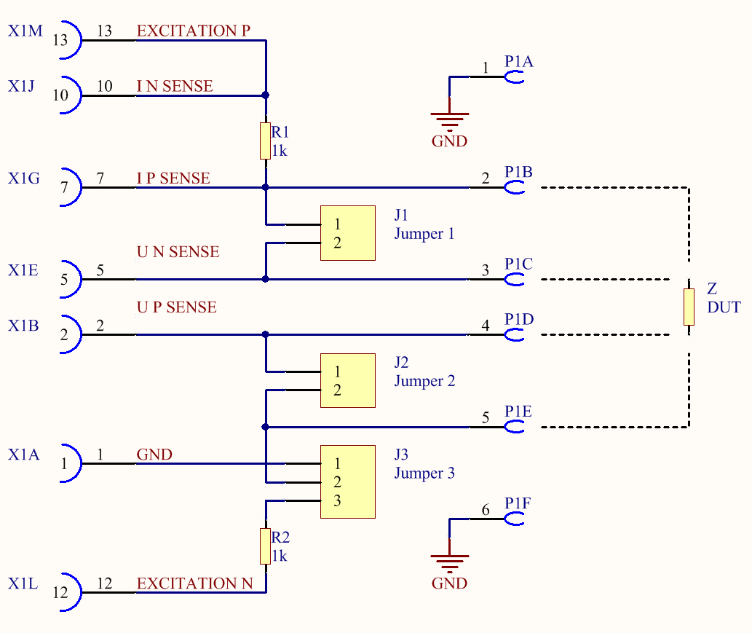

: Single shunt F.E schematic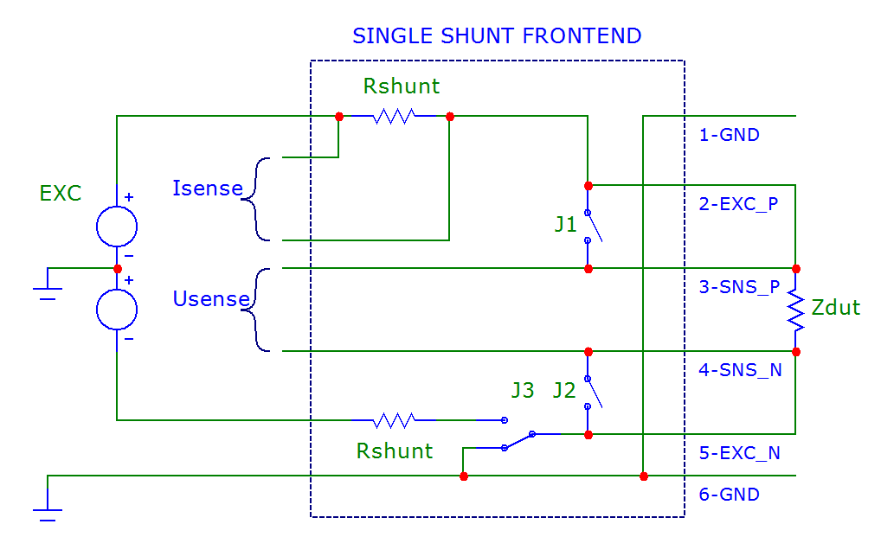

: Single shunt F.E. simplified schematic

**QUADRA Transimpedance Frontend.**

Transimpedance frontend uses voltage excitation with output impedance of 50 Ω to excitate the measured object and the current returning from the object is converted to voltage by transimpedance amplifier.

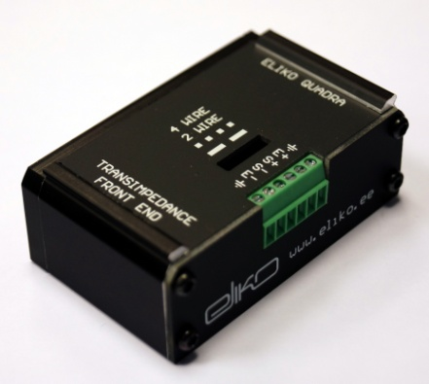

: Transimpedance F.E. image

Transimpedance amplifier has fixed current to voltage ratio. For instance with 1kΩ current to voltage conversion resistor 1mAp-p current through measured object results in 1Vp-p voltage at the output of transimpedance amplifier. Maximum allowed voltage, where the device is in the linear region is 3Vp-p.

Transimpedance frontend keeps both connections to the DUT at low impedance and thus decreasing the current leaking from measurement path and increasing noise-immunity.

Transimpedance frontend allows to select between four wire and two wire measurement conficurations by addition or removal of jumpers J1 and J2

Transimpedance frontend features an onboard memory-IC with the frontend identificator and calibration data. It is not required from user to fill this data to the graphical user interface manually.

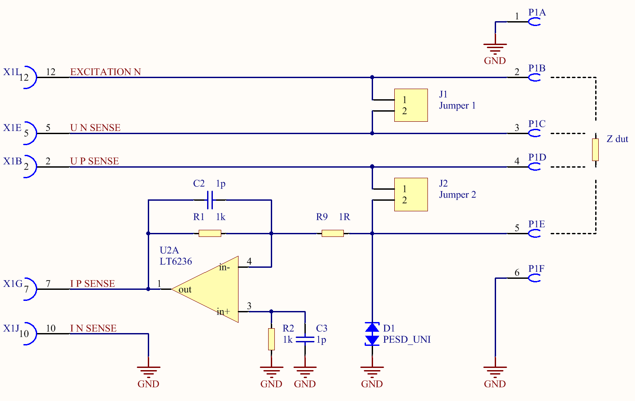

: Transimpedance F.E. schematic

**QUADRA Currentsource Frontend.**

Currentsource frontend uses currentsource with the voltage to current conversion factor of 1V=1mA for excitation of the Device under Test (DUT). Because of the parasitics, currentsources in practice work well only in moderately low frequencies (f<10kHz). At higher frequencies the excitation current leakes from the measurement path and the current that is performing actual excitation is less then the nominal output current of the currentsource. Therefore for better accuracy, transimpedance amplifier is implemented to the currentsource frontend to measure the current that is returning from the DUT

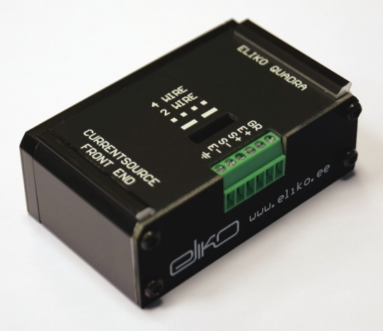

: Currentsource F.E. image

Currentsource frontend allows to select between four-wire and two-wire measurement conficurations by addition or removal of jumpers J1 and J2

Currentsource frontend features an onboard memory-IC with the frontend identificator and calibration data. It is not required from user to fill this data to the graphical user interface manually.

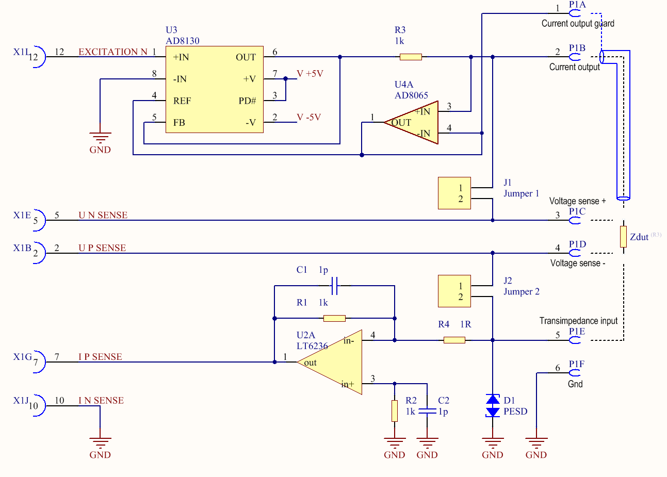

: Currentsource F.E. schematic

**QUADRA Multishunt Frontend DECODER.**

Multishunt frontend is populated with eight user or program selectable shunts. Shunts are switched based on the following table:

|  |  |  |  |
| --- | --- | --- | --- |
| **GPIO0** | **GPIO1** | **GPIO2** | **SHUNT** |
| 0 | 0 | 0 | A |
| 0 | 0 | 1 | B |
| 0 | 1 | 0 | C |
| 0 | 1 | 1 | D |
| 1 | 0 | 0 | E |
| 1 | 0 | 1 | F |
| 1 | 1 | 0 | G |
| 1 | 1 | 1 | H |

: Multishunt FE shunt selection table

|  |  |  |
| --- | --- | --- |
| **Index** | **Type** | **Value** |
| A | Resistor | 100Ω |
| B | Resistor | 1000Ω |
| C | Resistor | 10000Ω |
| D | Resistor | 100000Ω |
| E | Capacitor | 1nF |
| F | Capacitor | 10nF |
| G | Capacitor | 100nF |
| H | Capacitor | 1uF |

: Preliminary shunt values

Multishunt frontend is a good general front-end since a wide impedance range can be covered with 8 different shunts. Multishunt frontend allows automatic detection and application of the most appropriate shunt for the device under measurement.

The internal switches add some parasitic capacitance and therefore a single-shunt frontend with a well picked shunt value will provide better accuracy.

Multishunt frontend allows to select between four wire and two wire measurement conficurations by addition or removal of jumpers J1 and J2

Multishunt frontend features an onboard memory-IC with the frontend identificator and calibration data. It is not required from user to fill this data to the graphical user interface manually.

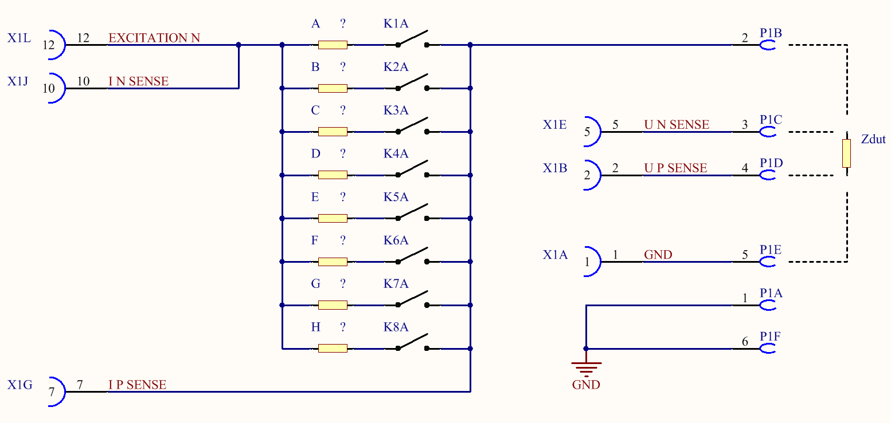

: Multishunt F.E. schematic

**QUADRA Multishunt Frontend I2C.**

Multishunt frontend is populated with eight user or program selectable shunts. Up to 3(preliminary) shunts can be switched simultaneously.

Shunts are switched by I2C issuing 2byte control command to address 0x20. To connect a shunt, bits marked with corresponding letters must be written to ’0’. Other bits must be set to ’1’. So for an example to connect shunt C, 0xF3(0b11110011) 0xFF(0b11111111) bust be written to address 0x20.

|  |  |  |
| --- | --- | --- |
| **Address** | **MSB** | **LSB** |
| 0b0100000(0x20) | 0bAABBCCDD | 0bHHGGFFEE |

|  |  |  |
| --- | --- | --- |
| **Index** | **Type** | **Value** |
| A | Resistor | 100Ω |
| B | Resistor | 1000Ω |
| C | Resistor | 10000Ω |
| D | Resistor | 100000Ω |
| E | Capacitor | 330pF |
| F | Capacitor | 3.3nF |
| G | Capacitor | 33nF |
| H | Inductor | 100uH |

: Preliminary shunt values

Multishunt frontend is a good general front-end since a wide impedance range can be covered with 8 different shunts. Multishunt frontend allows automatic detection and application of the most appropriate shunt for the device under measurement.

The internal switches add some parasitic capacitance and therefore a single-shunt frontend with a well picked shunt value will provide better accuracy.

Multishunt frontend allows to select between four wire and two wire measurement conficurations by addition or removal of jumpers J1 and J2

Multishunt frontend features an onboard memory-IC with the frontend identificator and calibration data. It is not required from user to fill this data to the graphical user interface manually.



: Multishunt F.E. schematic

**QUADRA Multiplexer Frontend.**

Multiplexer frontend uses voltage excitation (Rout ca 100Ω) and a transimpedance amplifier for measuring the excitation current.

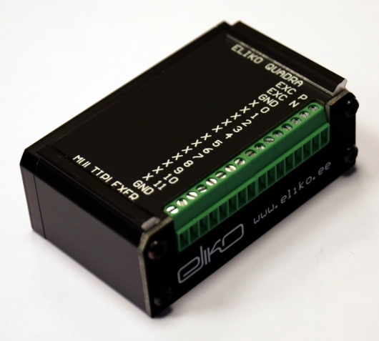

: Multiplexer F.E. image

There are twelve user definable signal pins to which can be connected to either positive voltage sense, negative voltage sense, negative excitation voltage, positive excitation voltage or ground. Also there are dedicated pins for excitation output and ground.

Internal I2C address is 0b1110000. Three bytes must be written: Address, Command1, Command2.

|  |  |  |
| --- | --- | --- |
| **Bit** | **Mnemonic** | **Description** |
| DB15 | Data | Controls the state of the switch. 0-switch off, 1-switch is on |
| DB14-DB11 | AX3-AX0 | Selects output between X0-X11 |
| DB10-DB08 | AY2-AY0 | Selects input (see table „input description“) |
| DB07-DB01 | X | Do not care |
| DB00 | LDSW | LDSW=1 – switch position changes after new word is read,  LDSW=0 – input data is latched, but switch position is not changed |

: Mux FE registry content

|  |  |
| --- | --- |
| **Description** | **DB10-DB08** |
| Excitation P | 111 |
| Excitation N | 110 |
| Sense P | 000 |
| Sense N | 001 |
| Transimpedance amplifier. input | 010 |
| GND | 011 |

: Mux input codes

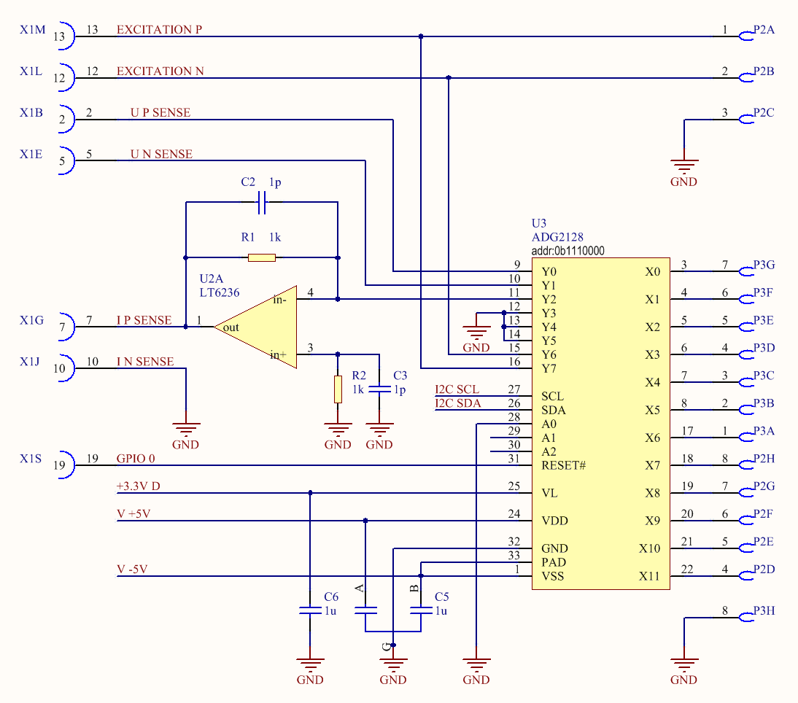

: Multiplexer F.E. schematic